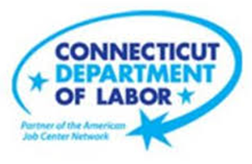

**NEW WEEKLY JOB POSTINGS FROM   
HELP WANTED ONLINE  
Office of Research**

**Week Ending June 18th, 2022:   
New Ads Down 20% Over the Week and Up 46% Over the Year**WETHERSFIELD, June 24th, 2022 – During the week ending June 18th, there were 9,501 new postings, down 2,423 new ads or -20% over the week. The most recent weekly new ad total drop is the fourth largest weekly drop of 2022 and follows the largest over the week increase in the graph shown below. Four Industries comprised a combined 49 percent of this overall increase; Finance & Insurance, Manufacturing, Pro., Sci. & Tech. Services, and Retail Trade. Employers with the largest over-the-week decrease include Amazon (-212 new ads), Panera Bread (-126 new ads), and Domino’s Pizza (-98 new ads). Occupations with the largest ad decrease over the week include Driver/Sales Workers (-207 new ads), Wholesale & Manufacturing Sales Reps (-89 new ads), and Customer Service Representatives (-61 new ads). This most recent week though down over the week is up 46 percent from a year ago.  
  
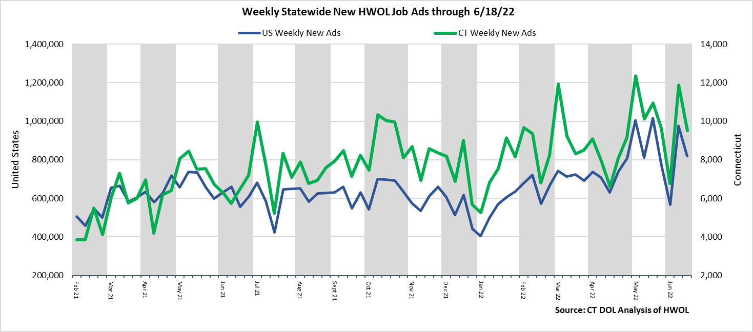  
**Industries** with the most new postings include Health Care & Social Assistance, Finance & Insurance, and Retail Trade.

**Occupations** with the most new postings include Registered Nurses, Retail Salespersons, Licensed Practical & Licensed Vocational Nurses.

**Employers** with the most new postings include Capital One, Yale-New Haven Health System, EverSource.

**The three industries with the most new job postings were:**

* **Health Care & Social Assistance** (1,990 new postings, -10% over the week)
* **Finance And Insurance** (936 new postings, -29% over the week)
* **Manufacturing** (800 new postings, -23% over the week)

  
 During the week ending June 18th, the total ad decline of 2,423 new ads or -20% is the net result of declines in all but two industries. The largest industry declines occurred in Finance & Insurance (-375 new ads), Manufacturing   
(-300 new ads), and Professional, Scientific, & Technical Services (-271 new ads). Over four weeks, every industry was down a combined 1,616 new ads, 16 of 21 industries decreased, and 5 increased. The most recent four-week change is a reversal of a week ago, which had 16 of 21 industries increasing and 5 decreasing over four weeks. The largest four week decreases occurred in Accommodation & Food Services (-259 new ads), Professional, Scientific, & Technical Services (-246 new ads), and Finance & Insurance (-180 new ads).   
  
For more information on total job ads by industry for Connecticut and its labor market areas, see the monthly report available here: <https://www1.ctdol.state.ct.us/lmi/hwol.asp>

**New Job Postings by Occupation** 

**The occupations with the most new postings were:**

* Registered Nurses (440 new postings, -9% over the week)
* Retail Salespersons (259 new postings, -12% over the week)
* Licensed Practical & Licensed Vocational Nurses (245 new ads, +75% over the week)

**Employers with the Most New Job Postings**

Employers with the most new job postings during the week were mostly in Health Care, Finance & Insurance, and Manufacturing. The 25 employers shown above account for 20 percent of all new ads. 16 of 25 employers in the top 25 had over the week increases, 1 was unchanged, and 8 declined. Over four weeks, 22 employers in the top 25 had increases and 3 had decreases. The largest increase over four weeks was Capital One (+153 new ads). The State of Connecticut and Walgreens both had the largest four week declines, down 13 jobs.   
  
**What is HWOL?**The **Conference Board Help Wanted Online**® Data Series (HWOL) measures the number of new, first-time Online job postings and jobs reposted from the previous month for over 16,000 Internet job boards, corporate boards and smaller job sites that serve niche markets and smaller geographic areas. To view more HWOL data, go to: <https://www1.ctdol.state.ct.us/lmi/hwol.asp>